HYPERTENSION DIAGNOSIS FORM – 7 DAYS
HOME BP MONITORING INFORMATION FOR THOSE NOT KNOWN TO HAVE HYPERTENSION
NAME……………………………………………………………………………………………………………………………………………….………
ADDRESS……………………………………………………………………………………………………………………………………………….……
DOB………………………………….… AGE…………………………………TEL…………………………………………………………..………….
MONITOR NUMBER …………………………..APPT TO RETURN MONITOR…………………………………………………………..
HOW TO TAKE BLOOD PRESSURE
- REMOVE ANY TIGHT CLOTHING FROM THE UPPER ARM
- SIT FOR 10 MINUTES WITH LEGS UNCROSSED BEFORE TAKING BP
- TAKE 2 BP READINGS 5 MINS APART AND RECORD THE LOWER OF THE 2 READINGS IN THE CHART BELOW.
- REPEAT THIS TWICE A DAY
SYSTOLIC IS THE TOP READING AND DIASTOLIC IS THE BOTTOM NUMBER IE 120/70
 | MORNING |  |  | EVENING
DATE | SYSTOLIC | DIASTOLIC |  | SYSTOLIC | DIASTOLIC
1
2
3
4
5
6
7

When you have completed your diary it would be very helpful if you could average the results – see the instructions below
IGNORE THE READINGS FROM DAY 1
Count how many blood pressure readings you have done in total – eg if you have done your BP twice a day for 6 days then the total number of readings should be 12 (REMEMBER TO IGNORE DAY 1 READINGS)
Then add up all the figures from the systolic columns – press equal – then divide that by the number of readings you have done (ie 12) then write that figure in the systolic box below
SYSTOLIC | DIASTOLIC
Repeat these steps but this time using the figures from the diastolic column and enter the result in the diastolic box below.
AVERAGE HOME BP

PTO
HEALTH INFORMATION

Current smoker . How many a day………………….. Ex-smoker Never smoked
In line with current guidelines, we advise you to stop smoking for your own well being. If you would like advice regarding stopping smoking then please visit www.smokefreehampshire.co.uk

Height……………………………………………..……………...Weight…………………………………………………………………………………

Alcohol units per week…………………………………………………………………………………………………………..……………………..
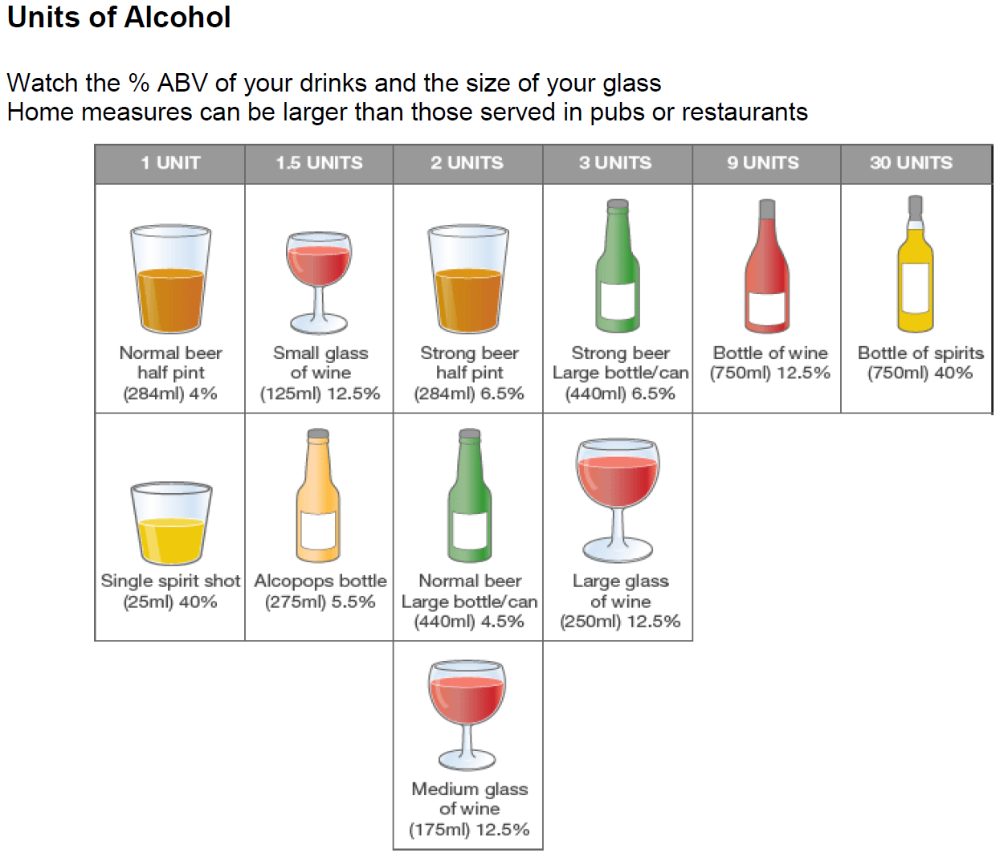

PLEASE RETURN THIS FORM AND THE MONITOR TO RECEPTION ON THE DATE GIVEN

