FAREHAM CENTRE PRACTICE (FCP)
PATIENT PARTICIPATION GROUP (PPG) NEWSLETTER
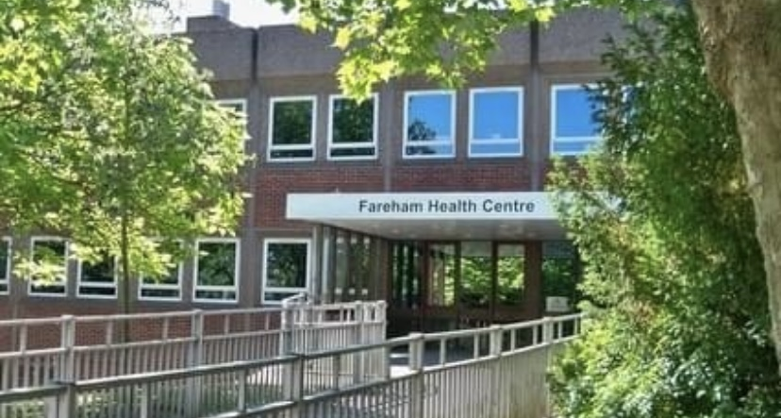
Hello and Welcome to issue 2 of our newsletter from the PPG members at the Fareham Centre Practice. We are a group of volunteer registered patients at the practice and our aim is to represent patient voices at the practice and to let you know any practice updates.
Do you have any improvement ideas to help improve the service you receive or concerns about the surgery that you would like to be discussed by the members. If so, please email the patient liaison officer or write a letter for the attention of the PPG Chair at the Fareham Centre Practice.
Join your PPG, if you would like to join the PPG please ask at reception or go on to the FCP website and complete the form. We look forward to hearing from you.

Todays contents:
- Pharmacy first - a new service
- Folate and other information for Pregnant Mums
3. Calcium for Seniors
1. Pharmacy First - The new NHS ‘Pharmacy First Service’ will enable community pharmacists to complete episodes of care for patients without the need for the patient to visit their general practice. Patients can now get treatment for seven common conditions directly from their local pharmacy, without the need for a GP appointment or prescription.
Pharmacies that have signed up for the service will be able to prescribe antibiotics or antivirals for the following:

Ear infections : 1-17 years old
Sore throat: 5 years and over
Sinusitis: 12 years and over
Uncomplicated Urine infections: 16-64 years (Women Only)
Impetigo: 1 year and over
Infected insect bites: 1 year and over
Shingles: 18 years and older

Ask your pharmacy if they have signed up for this service, most Pharmacies will have a poster in their window or dispensary if they have.

For further information copy and paste the link below:

https://healthmedia.blog.gov.uk/2024/02/01/pharmacy-first-what-you-need-to-know/

2. Pregnancy news
Before you get pregnant and as soon as you are even thinking about getting pregnant, you should start taking Folic acid. It’s important to take a 400 micrograms folic acid tablet every day before you're pregnant and until you're 12 weeks pregnant. Folic acid can help prevent birth defects known as neural tube defects, including spina bifida.
As soon as you become pregnant, you will need to refer yourself to the midwife service. The practice reception can advise you how to do this. This is so they can book your pregnancy (antenatal) care and make sure you get all the information and support you need to have a healthy pregnancy. Your first appointment with a midwife should happen before you're 10 weeks pregnant.

For further information please copy and paste the link below or contact the Fareham Health Centre.

https://www.nhs.uk/pregnancy/finding-out/your-pregnancy-to-do-list/

3. Calcium for Seniors
Calcium has several important functions. These include:
- helping build bones and keep teeth healthy
- regulating muscle contractions, including your heartbeat
- making sure blood clots normally

A lack of vitamin D and/or calcium could lead to a condition called rickets in children, and osteomalacia or osteoporosis in later life. Regular weight bearing exercise is proven to ensure your bones stay strong. The best exercise is walking and the more you do, the more you build bone strength which will last through life. The best time to start this was 10 years ago. The second-best time to start is now. (A take on an old Japanese proverb)
Please refer to this website for more information. https://theros.org.uk/information-and-support/osteoporosis/living-with-osteoporosis/exercise-and-physical-activity-for-osteoporosis/
Sources of calcium include: Milk, Cheese and other dairy products, Green leafy vegetables such as broccoli, curly kale, okra (but not spinach because although spinach does contain high levels of calcium the body cannot absorb it all). Substitute milk drinks with added calcium Bread and anything made with fortified flour Fish where you eat the bones – such as sardines and pilchards
How much Calcium do I need?

Adults aged 19 to 64 and over need 700mg of calcium a day. You should be able to get all the calcium you need from your daily diet.
Calcium supplements

Only take calcium supplements if recommended by your doctor or pharmacist. It is possible to overdose in which case you give your body the problem of how to dispose of the excess.
You are more likely to be short of vitamin D than short of calcium, in which case all the calcium in the world will not do any good because it will not be absorbed by your body. See newsletter number 1 for information on vitamin D.
Magnesium
One of the other things bones are made of is a mineral called Magnesium. You need both Magnesium and Calcium to build bones. Where do we get Magnesium from? Nuts, seeds, beans and of course, Green leafy vegetables.
No wonder the government pushes the “5 a day” message!
Osteoporosis symptoms and treatment | Looking after your bones | Age UK

Don’t forget if you have any improvement ideas to help improve the service you receive or concerns about the surgery that you would like to be discussed by the members. If so, please email the patient liaison officer or write a letter for the attention of the PPG Chair at the Fareham Centre Practice.
Join your PPG, if you would like to join the PPG please ask at reception or go on to the FHC website and complete the form. We look forward to hearing from you.

