Useful Contacts
- NHS Choices: www.nhs.uk
- Alzheimer’s Society National Dementia Helpline: 0300 222 11 22
Open 9.00am-5.00pm weekdays, 10.00am-4.00pm Saturday and Sunday
info@alzheimers.org.uk
The Alzheimer’s Society 02392 892034 – Services in New Forest, Fareham, Gosport, Havant, Petersfield & Bordon.
- Dementia UK: www.dementiauk.org
- Dementia Friends: www.dementiafriends.org.uk

Admiral Nursing DIRECT: 0800 888 6678
If you are a carer, you can self refer to Admiral Nurses who provide specialist nursing intervention, support and advice.

Join Dementia Research is a service run by Alzheimer's Society, Alzheimer's Research UK and the NHS through which you can register your interest in being contacted about potential research opportunities. Please visit www.joindementiaresearch.nihr.ac.uk or call 0300 222 1122

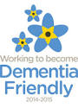
THE CENTRE PRACTICE
Healthcare at the heart of Fareham
www.farehamcentrepractice.co.uk

The Health Centre
Osborn Road
Fareham
Hampshire PO16 7ER

Tel: 01329 823456
Fax: 01329 285772

Patient & Family Information
Leaflet

Dementia is everyone’s business…..

“Living with Dementia rather than suffering from Dementia”

General Old Age | Dementia
Missing and occasional Payment | Not able to manage finances
Forgetting names (and remembering them later) | Forgetting people who have been in your life
Forgetting odd words | Not able to have a conversation
Losing things from time to time | Not being able to track back through your day to find them
Not remembering where you parked | Not remembering what colour/  make your car is
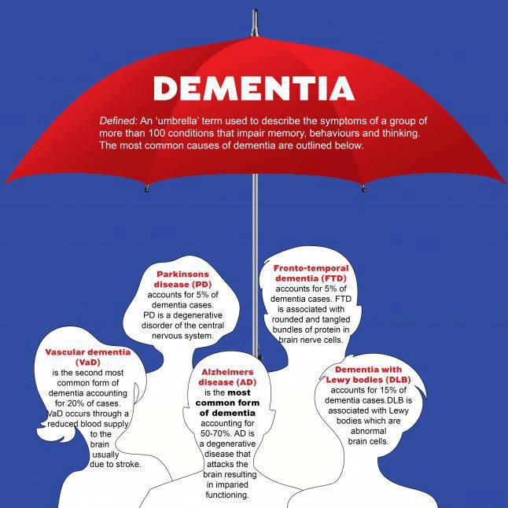

850,000 people in the UK have dementia (20,000 in Hampshire)
42,000 of these are under 65 (approx 5%)
The Risks of dementia increases as we get older; under 65 years it is 1 in 688, over 65 years it is 1 in 14, over 80 years it is 1 in 6.

Diagnosing dementia is often difficult, particularly in the early stages. Information can be found online at www.nhs.uk Your GP is often the first person to consult, so please do not hesitate to make an appointment.
An early diagnosis can help a person get information, advice and support, and enable them and their family to plan for the furture. It can also rule out other causes of confusion.
Some signs that Dementia is not always just the natural ageing process: -

Other symptoms of dementia are: Feeling anxious, depressed or angry about memory loss, or feeling confused- even when in a familiar environment.
Dementia is progressive, which means that the symptoms will get worse over time. It can happen to anyone and there is currently no cure, but treatments can slow the progression of the disease.
It is possible to live well with dementia; supported well, people with dementia are able to continue enjoying activities they have always enjoyed and to try new ones.

